Efficient Fault-Tolerant Multicast Scheme for Hypercube Multicomputers
Ge-Ming Chin and Kai-Shung Chen
IEEE Computer Society
Abstract
This paper presents a fault_tolerant multicast scheme for hypercube multicomputers. The method is based on the routing capability information that is stored in each node. In comparison with previous schemes , this information is able to capture the fault status more precisely. Two multicast algorithms are presented in this paper. These algorithm multicast messages in an attempt to minimize derouting so that time optimality can be achieved. Moreover, the routing capability information is used to guide derouting in an efficient manner when such needs arise. The amount of traffic incurred is addressed in the paper. The hardware design for the algorithms is also discussed. Extensive simulation has been conducted to evaluate the performance of the scheme.

Introduction
a. In this paper ,we use the concept of routing capability to assist fault-tolerant multicasts in hypercubes with faulty nodes.
b. Time optimality is said to be achieved for a destination if the length of the path form the source to the destination equals the shortest path length under fault-free conditions. The traffic of a multicast is quantified by the total number of distinct links the message traverses to reach all the destinations.
Preliminaries
- n-dimensional hypercube
- Hamming distance.
- A path is feasible if it includes no faulty nodes.
Fault-Tolerant multicast scheme
- Routing Capability：Let C_{A}^{k} be a binary digit denoting the routing capability of node A with respect to distance k, 1 ≦ k ≦ n .
- Node A is saide to be k-capable if C_{A}^{k} is 0 , otherwise , is not k-capable.
3. A faulty node F is not k-capable , and any nonfaulty node is automatically 1-capable.
- If a node has no less than k neighbors that are not (k-1)-capable, its routing capability with respect to distance k is set to 1.
- Routing matrix
- If node A is k-capable , for any nonfaulty node B for which H(A,B)=k , there exists a feasible minimum path of length k between A and B.
- Example :routing matrix M₀₁₀₁₀$\left[\begin{matrix}0 & 0 & 0 & 1 & 0 \\ 0 & 1 & 0 & 1 & 0 \\ 0 & 0 & 0 & 0 & 0 \\ 0 & 1 & 1 & 1 & 0 \\ 0 & 1 & 0 & 1 & 0\end{matrix}\right]$
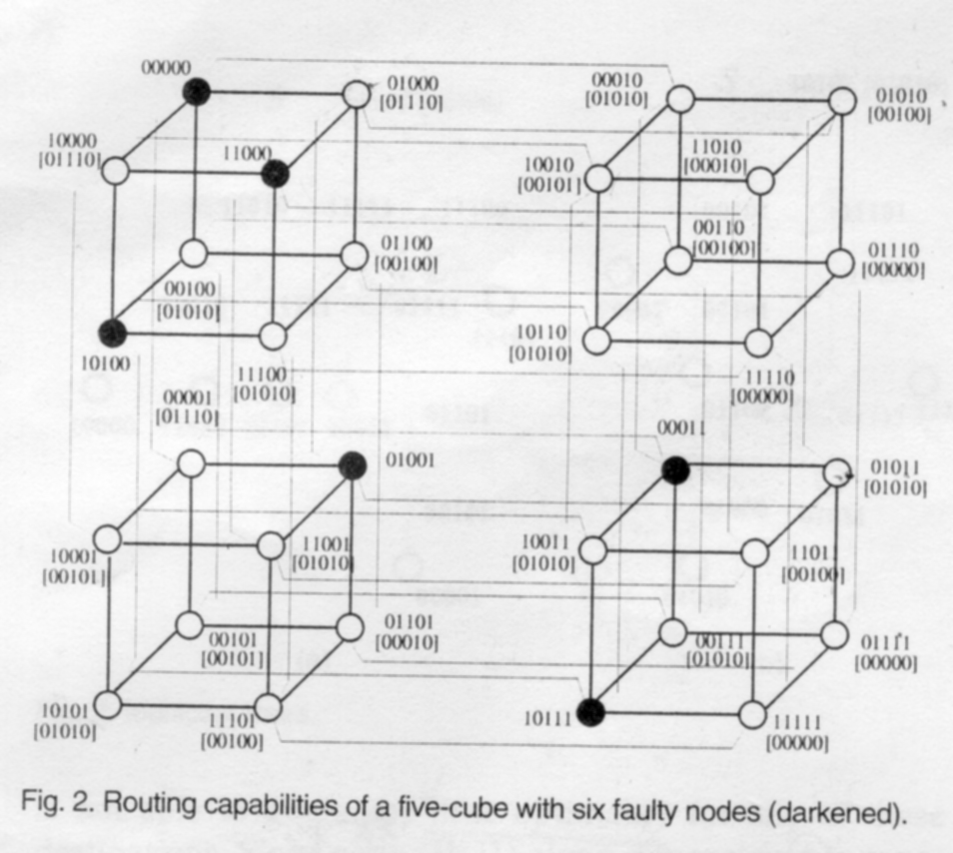

ASM Algorithm
We first present a greedy algorithm which is based on the address sum of the destination set D in determining the dimension to forward the message for a destination. This algorithm is a modified version of the greedy algorithm that is designed for fault-free hypercubes by incorporating the routing capabilities . Address sum of the destination set D ,denoted as as , is the sum of all R_{j}[I]. The values of as[I] is the number of destinations that are located in the opposite (n-1) dimensional subcube across dimension i.
(1) example 1
- Node S = ( 11110 )
- Destination set D =( 11001, 00001, 10000, 00111, 10101, 11101 )
- Relative addresses R =( 00111, 11111, 01110, 11001, 01011, 00011)
- As = (24355)
- Choose Dimension 3 and test (R_{i}(k)=1 and M_{C}[k][|R_{i}|-1]=0)
- F₃ contain U₆
- As=243-4
- Choose dimension 1 , Not able to guarantee time optimality for any of destinations
- Choose dimension 4 , F₄ ={ U₁,U₂,U₄,U₅}
- As=00100
- Choose dimension 2 ,F₂=U₃
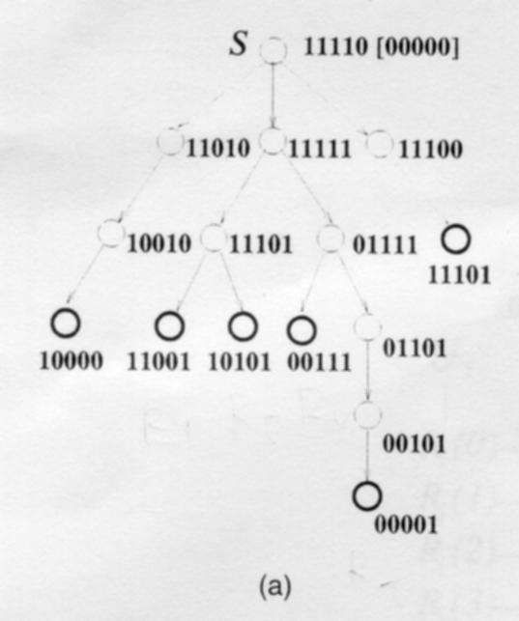

(2) example 2
- Node S = (10101)
- Destination set D=( 01100, 01011, 00001, 01010, 11110 )
- Relative addresses R=(11001, 11110, 10100, 11111, 01011 )
- As = ( 44333 )
- Choose Dimension 0
- F₀={ U1, U3 ,U4 }
- F₁={U₅}
- Time optimality cannot be guaranteed for U₂ .
- Must deroute
- F₁={U₂, U₅}.
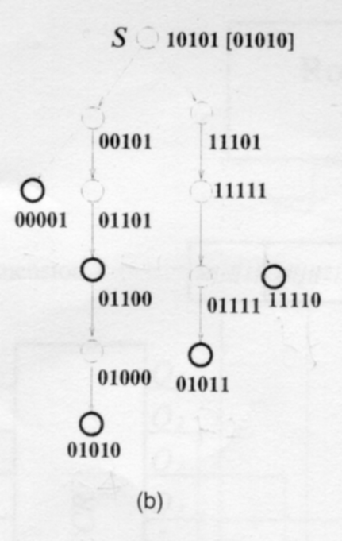
MPM Algorithm
The amount of traffic is always a major concern of multicast communication . In ASM , priority is given to the dimension with the largest corresponding address sum value when forwarding a message to a destination , in an attempt to reduce communication traffic.
MPM is intends to remedy this deficiency while not sacrificing time optimality and reachability.
- example 1
a. Node S = ( 11110 )
b. Destination set D =( 11001, 00001, 10000, 00111, 10101, 11101 )
c. Relative addresses R =( 00111, 11111, 01110, 11001, 01011, 00011)
d. F₀={U₂,U₄}, F₁=empty , F₂={U₁, U₃} , F₃= {U₆} ,F₄={U₁,U₂,U₄,U_{5,} U₆}
e. Choose dimension 4 and dimension 2
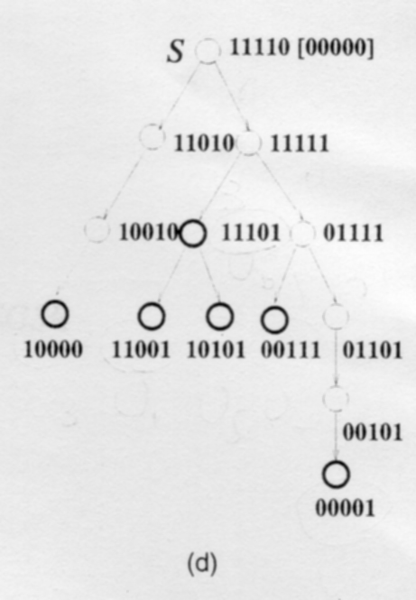
Hardware implementation
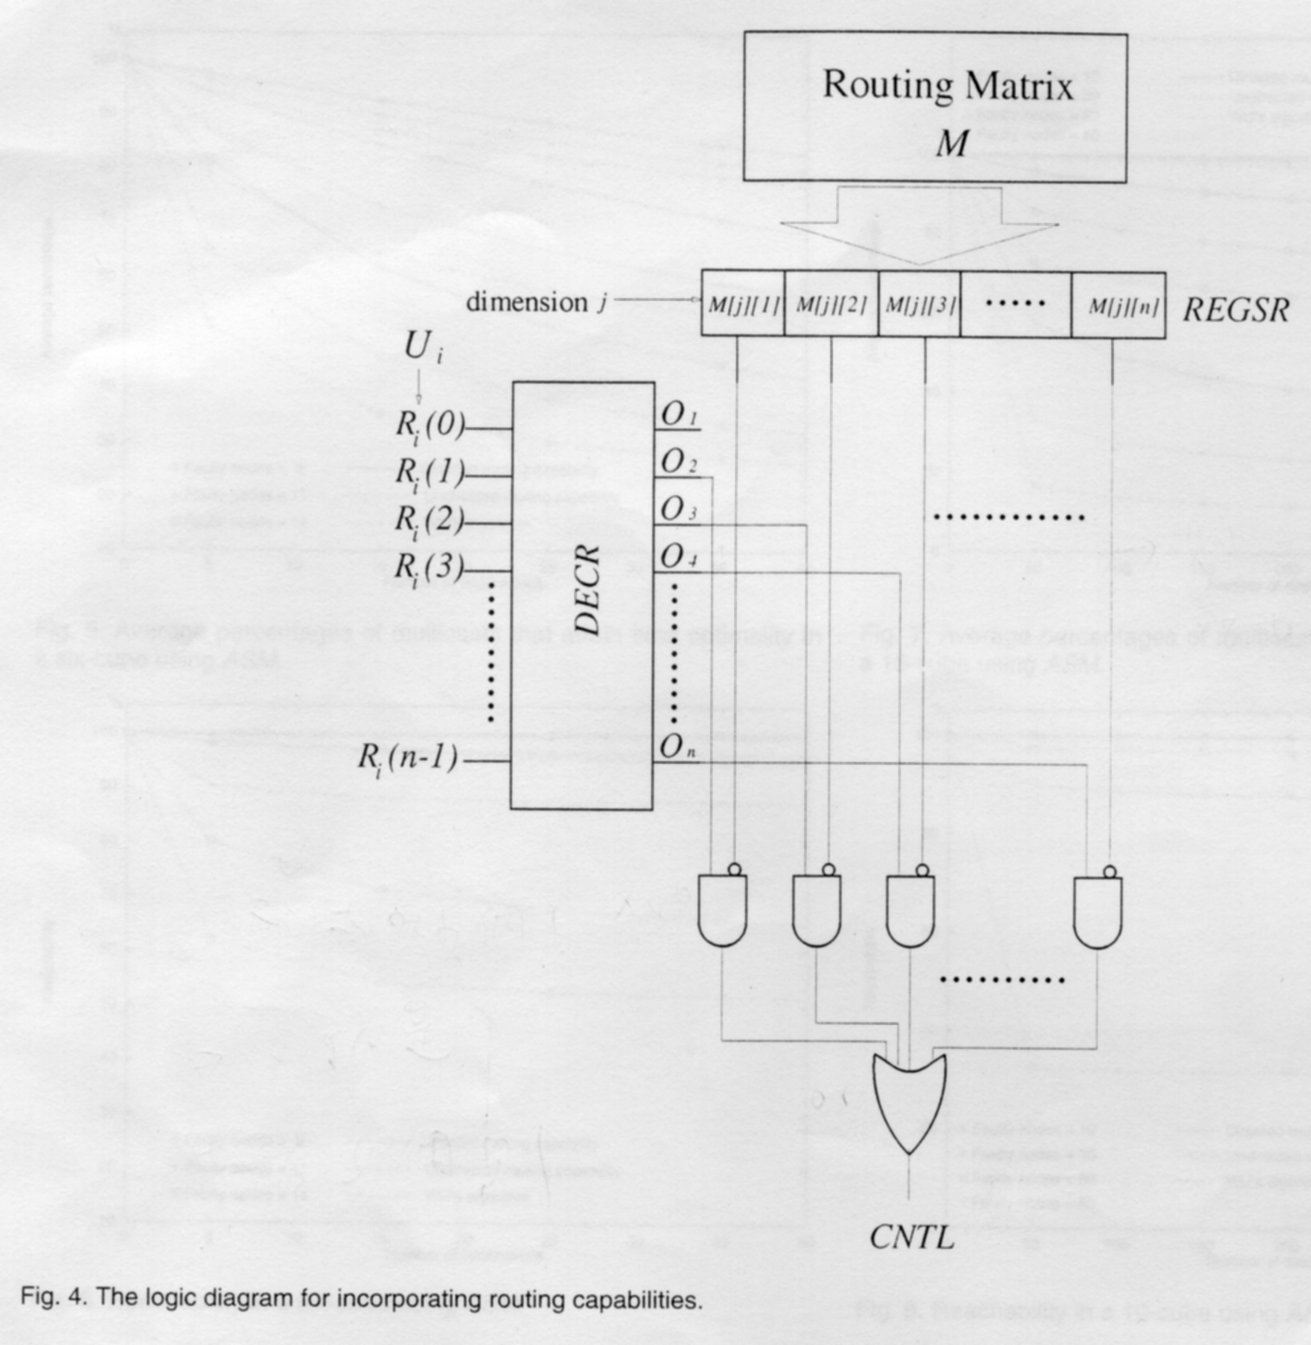
Directed Routing Capability
1 If node A in a hypercube determines that it is k-capable with directed routing capability , for any nonfaulty node B for which H(A,B)=k , there exists a feasible shortest path of length equal to k from A to B
2. Use of directed routing capabilities in ROUTE has one drawback. Recall that the information contained in a routing matrix can be used to guarantee a bound on the requirement of derouting when undirected routing capabilities are used in ROUTE. This property no longer holds with the directed routing capability. This is due to the fact that an entry of a node's routing matrix being 0 is not necessarily accompanied by that the corresponding neighbor of the node is actually capable with respect to the associated distance.

Conclusion
Future research may include extending the idea of routing capability to other topologies such as meshes. Tori, and low-dimensional networks

